EHR-Generated Patient Education with Krames-Staywell Videos

Overview
With the release of the CQIC Q2-2012 clinical content, the updated Patient Instructions-CCC form now has the ability to generate patient-specific educational material for distribution at the point of care.

Clinical Content Consultants (CCC) has entered into a business relationship with Krames-Staywell to facilitate access to an extensive library of patient education videos (see reference list below). Under the current agreement, sites may purchase access to up to seventy (70) video titles per specialty from the Krames-Staywell library of videos. Using the new Video List-TFE, each site can designate, by specialty, which seventy (70) videos they may access. These videos can then display within the Education Tab of the updated Patient Instructions-CCC form, based on patient-specific metrics. These metrics are provided by CCC as part of the Krames-Staywell subscription but can be edited using the new Patient Instruction-TFE.

Pricing
The Krames-Staywell CCC Video Integration license is $120 per provider per year.

Licensing and Site Authorization
Each site decides how many provider licenses and how many Locations of Care they want to have access to the Krames-Staywell videos. A CCC-fndef-Video-Auth.ccc file will be provided granting access to the specified number of providers and locations of care. Your site decides which user login names and locations of care will have access to the Krames-Staywell videos. You can modify the actual users and locations of care as long as you do not exceed the authorized number by using the new Video List-TFE.

The licensing subscription is for one year and can be renewed annually.

How to Subscribe
Any site interested in the Krames-Staywell patient education video subscription should complete the Krames-Staywell_CCC_Integration_Quote-Agreement.xlsx which will serve as the subscription request, price quote, and licensing agreement for their site. Once completed, a signed copy should be sent to sales@clinicalcontent.com or faxed to (603)386-6586.

Upon receipt of the completed and signed Krames-Staywell_CCC_Integration_Quote-Agreement.xlsx, your site will receive a Krames-Staywell CCC Integration Kit which includes your site’s CCC-fndef-Video-Auth.ccc file.

Krames-Staywell Video Titles & CCC Integration Available
Please refer to the Krames_videolist.pdf provided for a complete listing, by specialty, of the Krames-Staywell patient education video titles.

As part of the Krames-Staywell CCC Integration Kit, CCC will provide an edited CCCQE-User-Edit-Videos-1.txt file for your site with all the pre-built metrics and video links by specialty. Below are examples of the recommended video links by specialty:

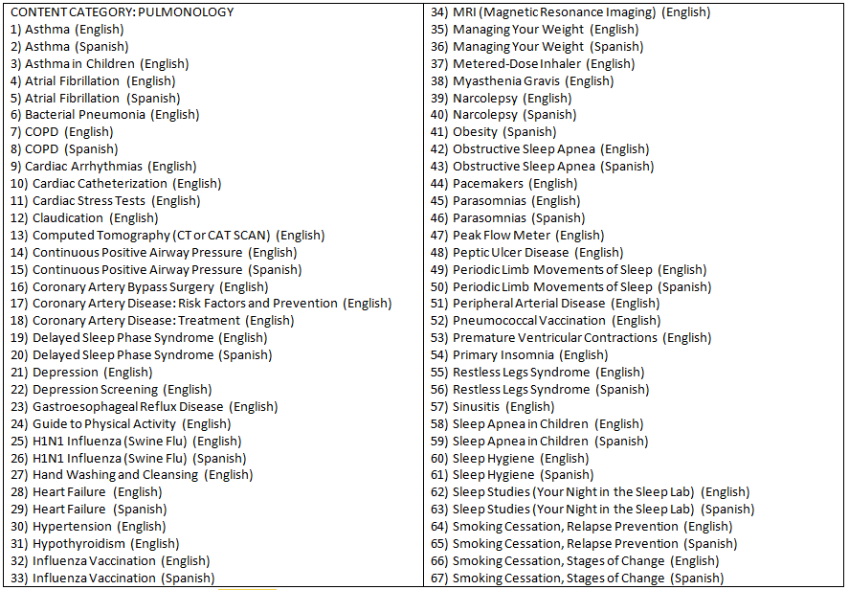

Pulmonary/Pulmonology Content (English/Spanish)

The CCCQE-User-Edit-Videos-1.txt file for your site with all the pre-built metrics and video links by specialty provided by CCC displays the recommended videos based on patient age, gender, diagnosis (inclusionary/exclusionary), medications (inclusionary/exclusionary), and observation terms with parameters (empty, not empty, =, <>, contains, not contains, >, >=, <, <=, btw, due date).

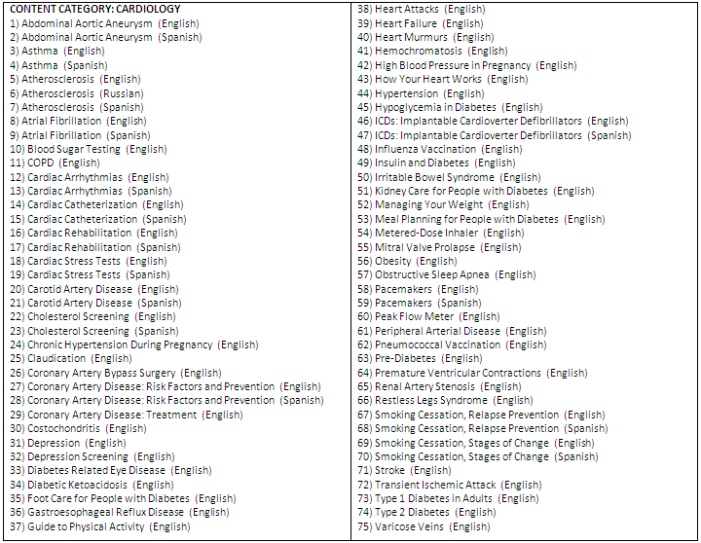

Cardiology Content (English/Spanish)

The CCCQE-User-Edit-Videos-1.txt file for your site with all the pre-built metrics and video links by specialty provided by CCC displays the recommended videos based on patient age, gender, diagnosis (inclusionary/exclusionary), medications (inclusionary/exclusionary), and observation terms with parameters (empty, not empty, =, <>, contains, not contains, >, >=, <, <=, btw, due date).

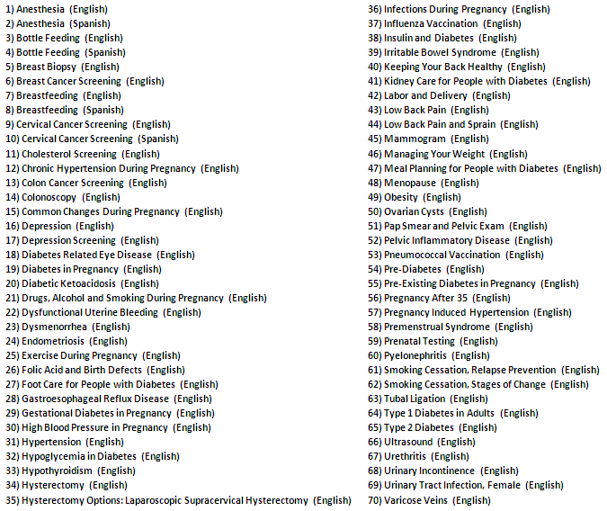

OB-Gyn Content (English/Spanish)

The CCCQE-User-Edit-Videos-1.txt file for your site with all the pre-built metrics and video links by specialty provided by CCC displays the recommended videos based on patient age, gender, diagnosis (inclusionary/exclusionary), medications (inclusionary/exclusionary), and observation terms with parameters (empty, not empty, =, <>, contains, not contains, >, >=, <, <=, btw, due date).

In addition to gender, can also designate pregnant female patient based on the number of weeks gestation range (example: 1-42 weeks or any combination).

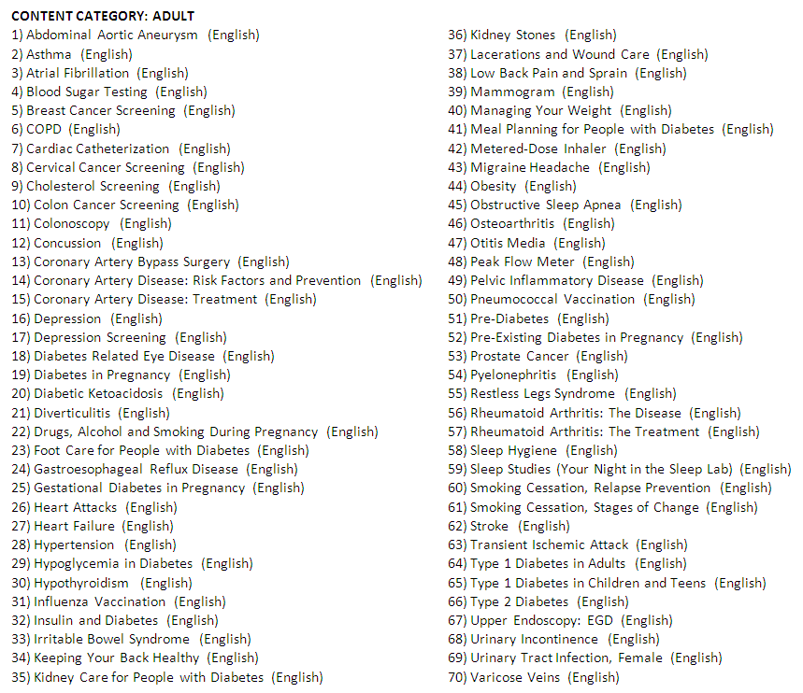

Primary Care (Family Medicine/Internal Medicine) Content (English/Spanish)

The CCCQE-User-Edit-Videos-1.txt file for your site with all the pre-built metrics and video links by specialty provided by CCC displays the recommended videos based on patient age, gender, diagnosis (inclusionary/exclusionary), medications (inclusionary/exclusionary), and observation terms with parameters (empty, not empty, =, <>, contains, not contains, >, >=, <, <=, btw, due date).

In addition to gender, can also designate pregnant female patient based on the number of weeks gestation range (example: 1-42 weeks or any combination).

